Comparative Life Cycle Assessment of a Reusable Water Bottle vs. Single-use Plastic Bottles

Table of Contents

Step 1: Goal and Scope Definition 3

Step 2: Life Cycle Inventory (LCI) 3

Life Cycle Inventory- Data Sources and Calculation: 4

CO₂ Emissions Calculations: 4

System Boundary Diagram: 5

Step 3: Life Cycle Impact Assessment (LCIA) 6

3.1 Define Impact Categories and Methods: 6

3.2 Apply Impact Factors to your Inventory: 6

3.3 Calculate Total Impacts: 6

Step 4 Interpretation: 7

Conclusion: 7

# Step 1: Goal and Scope Definition

This study aims to compare the environmental impact of using a reusable stainless steel water bottle versus using single-use plastic (PET) bottles over one year. The goal is to provide a clear, evidence-based comparison to help consumers make more sustainable choices in daily life. While designed for general public awareness, the study also follows basic Life Cycle Assessment (LCA) methodology, which is suitable for academic review.

The functional unit for this comparison is the delivery of 365 liters of drinkingwater to a single user over one year, equivalent to consuming 1 liter per day. This enables a fair comparison between using one reusable bottle (used and washed daily) and using 365 single-use bottles.

The system boundaries cover the full life cycle — cradle-to-grave — including:

* Raw material extraction
* Manufacturing
* Transportation
* Usage (including daily washing for reusable bottle)
* End-of-life (landfilling, recycling, or incineration)

The following impact categories are assessed:

* Global Warming Potential (GWP) – kg CO₂-equivalent
* Energy use – MJ (megajoules)
* Water use – liters

# Step 2: Life Cycle Inventory (LCI)

|  |  |  |
| --- | --- | --- |
| **Category** | **Reusable Bottle** | **Single-Use PET Bottle** |
| Units | 1 bottle reused 365 times | 365 bottles |
| Materials (kg) | 0.5 kg stainless steel | 7.3 kg PET (365*0.02 kg) |
| Bottle Manufacturing Energy (MJ) | 50 MJ | 15.3 MJ (365*0.042 MJ) |
| Transportation Energy | 3 MJ | 36.5 MJ (0.1 MJ/bottle) |
| Washing (water, soap) | 0.3 L+ 0.1 MJ/day = 109.5 L, 36.5MJ/year | 0 |
| End-of-life | 70% recycled | 30% recycled |
| CO2 from Manufacturing (kg CO2) | 7kg | 182.5kg |
| CO2 from transport (kg CO2) | 6.3kg | 0.091kg |
| CO2 from Washing (kg CO2) | 1.07kg | 0 |

## Life Cycle Inventory- Data Sources and Calculation:

The life cycle inventory for this study uses region-specific and literature-based values:

**Electricity**: We use the average German emissions intensity of **0.321 kg CO₂/kWh**, adjusted to **0.105 kg CO₂/kWh** to reflect the Bavarian electricity mix.

**Road Freight**: An emission factor of **0.126 kg CO₂ per tonne‑km** is applied, based on German data for heavy goods transport.

**Manufacturing impacts** use standard LCI values from **Ecoinvent** and **PlasticsEurope**:

Stainless steel bottle production: ~14 kg CO₂/kg → 0.5 kg = 7 kg CO₂

PET bottles: ~0.5 kg CO₂ per 0.02 kg bottle → 365 × 0.5 = 182 kg CO₂

**Washing impacts** (water, soap, heating): 0.3 L + 0.1 MJ per wash, multiplied by 365 uses, based on typical dishwashing LCA data.

**End-of-life assumptions**: 70% recycling for stainless steel (EU average), 30% for PET (current German average).

## CO₂ Emissions Calculations:

1. Electricity-related CO₂ (cleaning & manufacturing):  
   Energy (kWh)×0.321 kgCO2/kWh
2. Transport CO₂:
   * Reusable:  
     100 km × 0.5 tonnes × 0.126 kg = ~6.3 kg CO₂
   * Single-use:  
     (7.3 kg total weight) × (100 km × 0.126) / 1000 = ~0.092 kg CO₂ per total shipments  
     (Alternatively, use 0.1 MJ energy * avg electricity CO₂)
3. Production Emissions:
   * Stainless steel: ~14 kg CO₂ per kg → 0.5 kg ≈ 7 kg CO2
   * PET: ~0.5 kg CO₂ per bottle → 365 × 0.5 = ~182 kg CO₂  
     (**Values from Ecoinvent/PlasticsEurope**)

## System Boundary Diagram:

**Reusable bottle System (Cradle to Grave)**

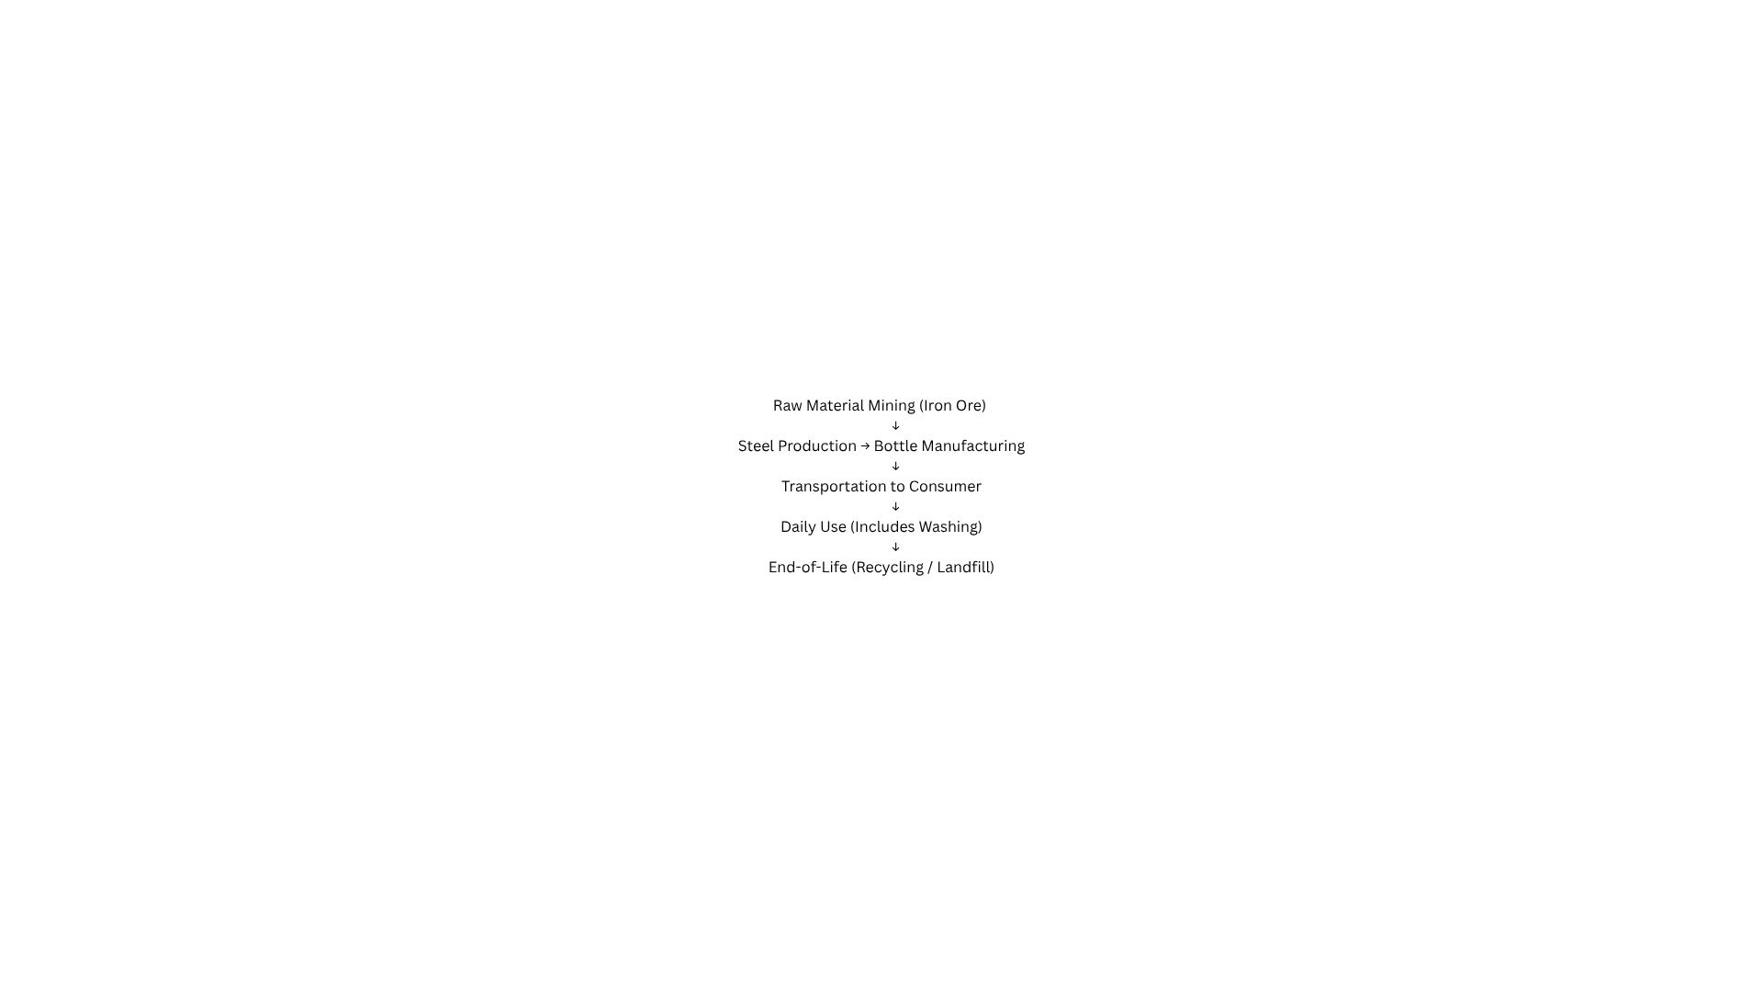

**Single-Use PET Bottle System**

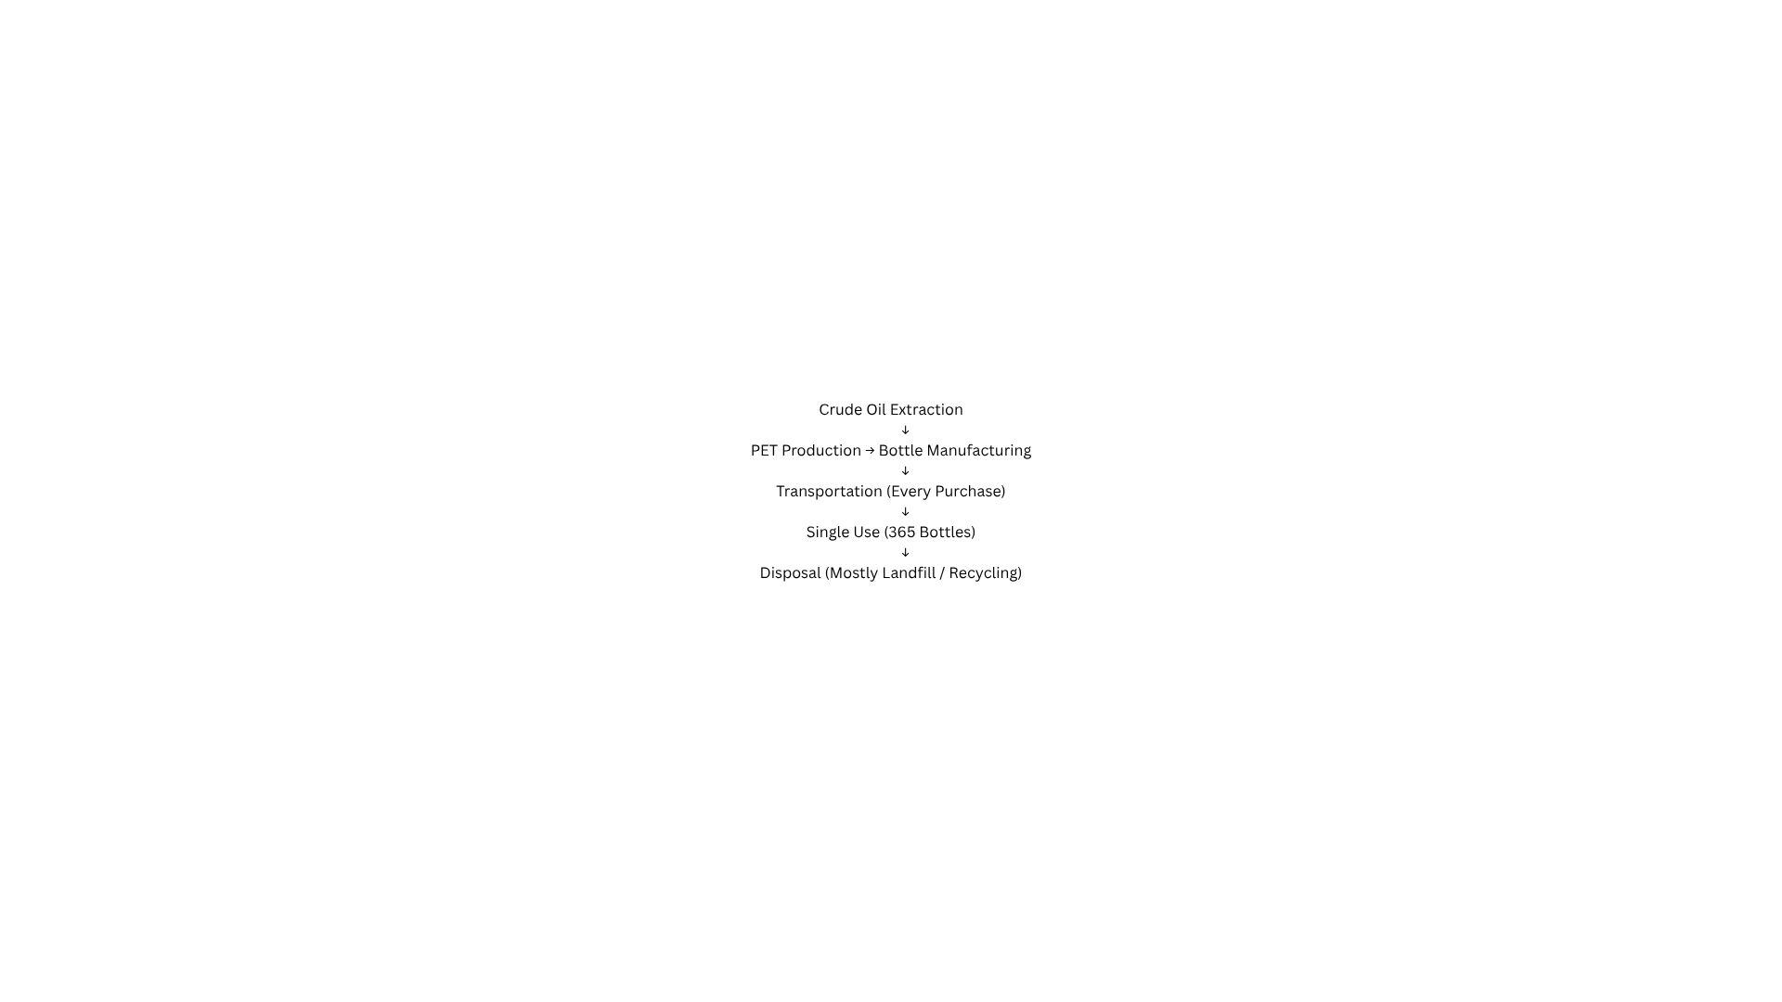

# Step 3: Life Cycle Impact Assessment (LCIA)

## 3.1 Define Impact Categories and Methods:

* 1. Global Warming Potential (GWP) – measured in kg CO2-equivalent
  2. Energy Use – total energy input in MJ
  3. Water Use – total liters consumed

## 3.2 Apply Impact Factors to your Inventory:

We’ll now calculate the impact for each item from your LCI using **conversion factors** (also known as characterization factors).

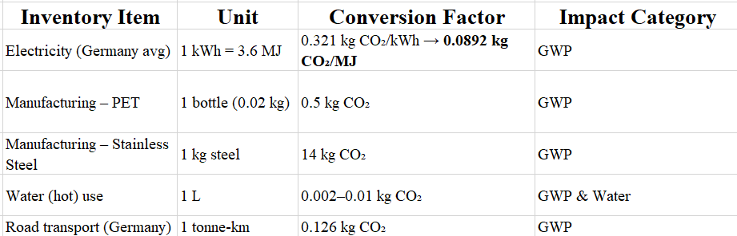

## 3.3 Calculate Total Impacts:

Reusable bottle (Steel):

1. GWP Total =

* Manufacturing: 0.5 kg steel * 14 kg CO2/kg = 7 kg CO2
* Washing = 36.5 MJ * 0.0892 kg CO2/MJ = 3.26 kg CO2
* Transport = 100 km * 0.5 tonnes * 0.126 = 6.3 kg CO2
* Total = 16.56 kg CO2

1. Energy Use = 50 MJ + 3 MJ + 36.5 MJ = 89.5 MJ
2. Water Use (Lit) = 0.3 L/day * 365 days = 109.5 L/year

Single-Use PET Bottles:

1. GWP Total =

* Manufacturing: 365 bottles * 0.5 kg CO2/bottle = 182.5 kg CO2
* Transport = 7.3 kg * 100 km * 0.126 CO2/ton-km / 1000 = 0.091 kg CO2
* Washing = 0 (No washing needed)

1. Energy Use = 15.3 MJ + 36.5 MJ = 51.8 MJ
2. Water Use = 0 (bottles are discarded after use)

# Step 4 Interpretation:

This study compared the environmental impacts of using a reusable stainless steel water bottle versus 365 single-use PET plastic bottles over one year (365 liters of drinking water). Impacts were assessed using Global Warming Potential (kg CO₂-eq), energy use (MJ), and water use (L).

**Impact Summary Table:**

|  |  |  |
| --- | --- | --- |
| **Impact Category** | **Reusable Bottle** | **Single-Use PET Bottle** |
| GWP (kg CO2-eq) | 16.56 | 182.6 |
| Energy Use (MJ) | 89.5 | 51.8 |
| Water Use (L) | 109.5 | 0 |

Over the course of one year, the **reusable bottle had ~91% lower carbon emissions** than the single-use plastic bottles. While it required more energy and water (mainly for cleaning), its emissions savings far outweighed these impacts. For example, if the stainless-steel bottle is only reused 50 times and then discarded, its GWP per liter would increase significantly and may not outperform PET. However, at 365 uses or more, the break-even point is quickly surpassed.

# Conclusion:

The results of this study show that a reusable stainless-steel bottle has a significantly lower environmental impact than using 365 single-use PET plastic bottles over one year, especially in terms of carbon emissions. While the reusable bottle requires more energy and water during use, its long-term benefits make it a more sustainable choice when used consistently and cleaned efficiently.